**Spring Boot with Microservices:**

1. **Spring Cloud Config Server:**

**Spring Cloud Config provides server and client-side support for externalized configuration in a distributed system.** With the Config Server you have a central place to manage external properties for applications across all environments. The concepts on both client and server map identically to the Spring Environment and Property Source abstractions, so they fit very well with Spring applications, but can be used with any application running in any language. ***As an application moves through the deployment pipeline from dev to test and into production you can manage the configuration between those environments and be certain that applications have everything they need to run when they migrate. The default implementation of the server storage backend uses git so it easily supports labelled versions of configuration environments, as well as being accessible to a wide range of tooling for managing the content. It is easy to add alternative implementations and plug them in with Spring configuration.***

**Note:** It suggests to **keep properties / resources in the environment of the server where the values of those resources vary during run time** – usually different configurations that will differ in each environment.

**SpringCloudConfigServerApplication.java:**

**package** com.udemy.microservices.springcloudconfigserver;

**import** org.springframework.boot.SpringApplication;

**import** org.springframework.boot.autoconfigure.SpringBootApplication;

**import** org.springframework.cloud.config.server.EnableConfigServer;

@EnableConfigServer

@SpringBootApplication

**public** **class** SpringCloudConfigServerApplication {

**public** **static** **void** main(String[] args) {

SpringApplication.*run*(SpringCloudConfigServerApplication.**class**, args);

}

}

**application.properties:**

spring.application.name=spring-cloud-config-server

server.port=8888

spring.cloud.config.server.git.uri=E:/git-localConfig-Repo

**limits-service-dev.properties:**

limits-service.minimum=100

#limits-service.maximum=10000

**limits-service-qa.properties:**

limits-service.minimum=10

limits-service.maximum=20000

**limits-service.properties:**

limits-service.minimum=800

limits-service.maximum=80000

management.security.enabled=false

**pom.xml:**

<?xml version=*"1.0"* encoding=*"UTF-8"*?>

<project xmlns=*"http://maven.apache.org/POM/4.0.0"*

xmlns:xsi=*"http://www.w3.org/2001/XMLSchema-instance"*

xsi:schemaLocation=*"http://maven.apache.org/POM/4.0.0 http://maven.apache.org/xsd/maven-4.0.0.xsd"*>

<modelVersion>4.0.0</modelVersion>

<parent>

<groupId>org.springframework.boot</groupId>

<artifactId>spring-boot-starter-parent</artifactId>

<version>2.2.0.M4</version>

<relativePath /> <!-- lookup parent from repository -->

</parent>

<groupId>com.udemy.microservices</groupId>

<artifactId>spring-cloud-config-server</artifactId>

<version>0.0.1-SNAPSHOT</version>

<packaging>war</packaging>

<name>spring-cloud-config-server</name>

<description>Demo project for Spring Boot</description>

<properties>

<java.version>1.8</java.version>

<spring-cloud.version>Hoxton.M1</spring-cloud.version>

</properties>

<dependencies>

<dependency>

<groupId>org.springframework.boot</groupId>

<artifactId>spring-boot-starter-web</artifactId>

</dependency>

<dependency>

<groupId>org.springframework.cloud</groupId>

<artifactId>spring-cloud-config-server</artifactId>

</dependency>

<dependency>

<groupId>org.springframework.cloud</groupId>

<artifactId>spring-cloud-starter-bus-amqp</artifactId>

</dependency>

<dependency>

<groupId>org.springframework.boot</groupId>

<artifactId>spring-boot-devtools</artifactId>

<scope>runtime</scope>

<optional>true</optional>

</dependency>

<dependency>

<groupId>org.springframework.boot</groupId>

<artifactId>spring-boot-starter-tomcat</artifactId>

<scope>provided</scope>

</dependency>

<dependency>

<groupId>org.springframework.boot</groupId>

<artifactId>spring-boot-starter-test</artifactId>

<scope>test</scope>

<exclusions>

<exclusion>

<groupId>org.junit.vintage</groupId>

<artifactId>junit-vintage-engine</artifactId>

</exclusion>

<exclusion>

<groupId>junit</groupId>

<artifactId>junit</artifactId>

</exclusion>

</exclusions>

</dependency>

</dependencies>

<dependencyManagement>

<dependencies>

<dependency>

<groupId>org.springframework.cloud</groupId>

<artifactId>spring-cloud-dependencies</artifactId>

<version>${spring-cloud.version}</version>

<type>pom</type>

<scope>import</scope>

</dependency>

</dependencies>

</dependencyManagement>

<build>

<plugins>

<plugin>

<groupId>org.springframework.boot</groupId>

<artifactId>spring-boot-maven-plugin</artifactId>

</plugin>

</plugins>

</build>

<repositories>

<repository>

<id>spring-snapshots</id>

<name>Spring Snapshots</name>

<url>https://repo.spring.io/snapshot</url>

<snapshots>

<enabled>true</enabled>

</snapshots>

</repository>

<repository>

<id>spring-milestones</id>

<name>Spring Milestones</name>

<url>https://repo.spring.io/milestone</url>

</repository>

</repositories>

<pluginRepositories>

<pluginRepository>

<id>spring-snapshots</id>

<name>Spring Snapshots</name>

<url>https://repo.spring.io/snapshot</url>

<snapshots>

<enabled>true</enabled>

</snapshots>

</pluginRepository>

<pluginRepository>

<id>spring-milestones</id>

<name>Spring Milestones</name>

<url>https://repo.spring.io/milestone</url>

</pluginRepository>

</pluginRepositories>

</project>

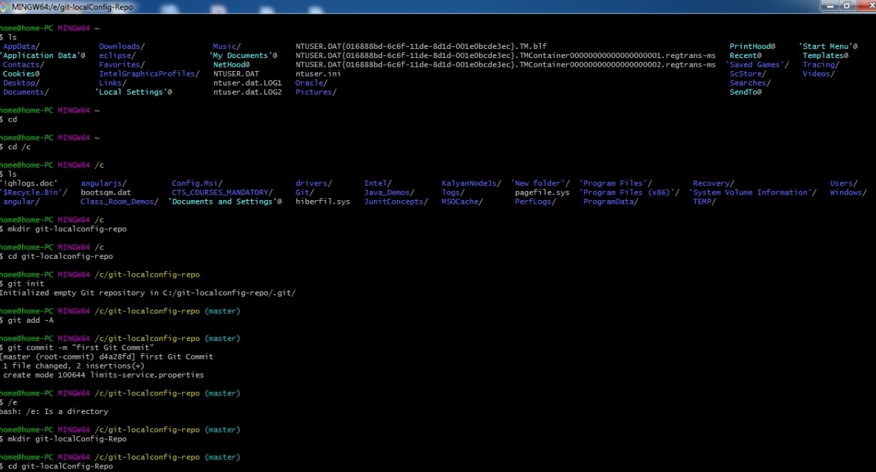

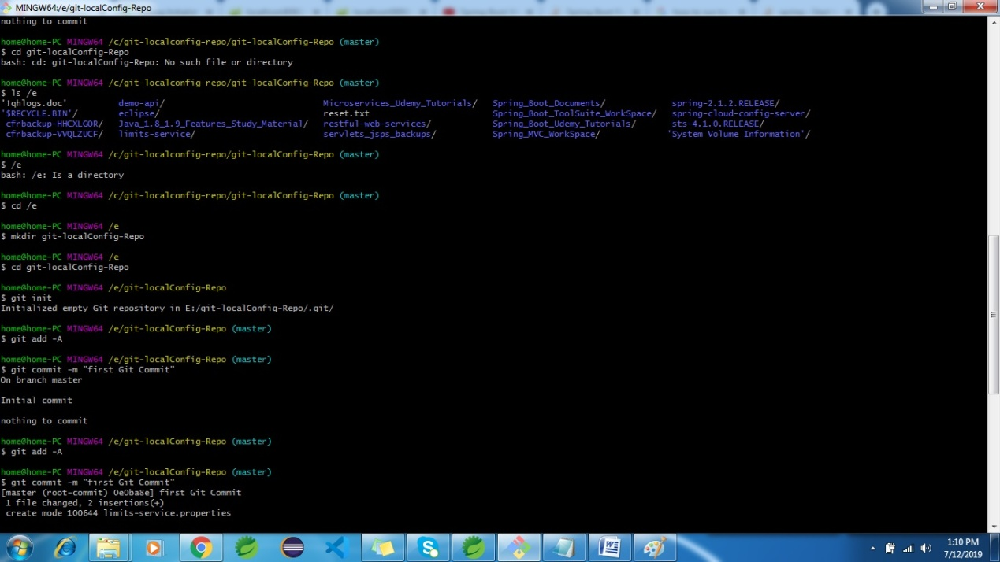

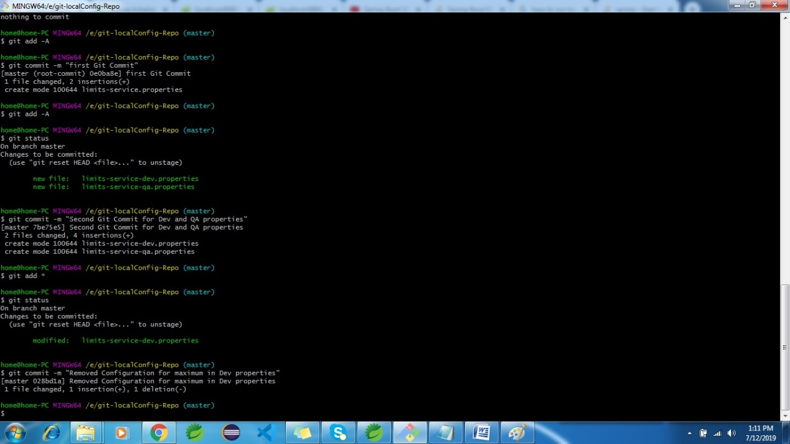

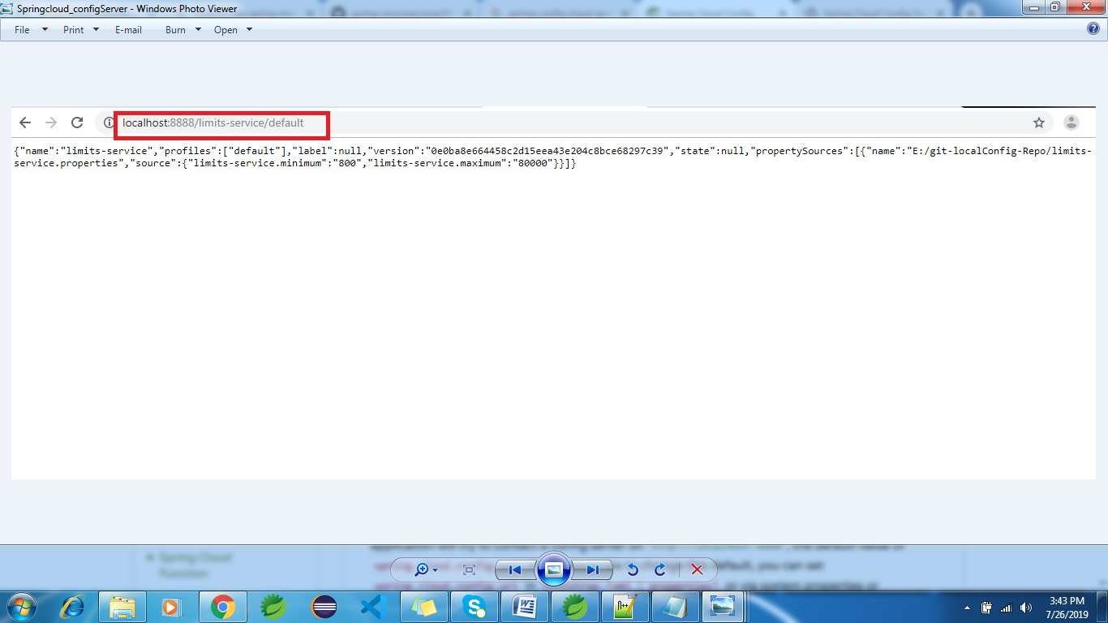

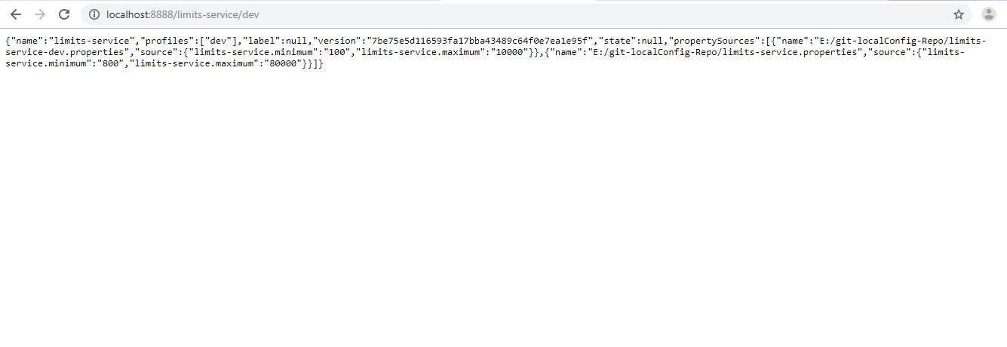

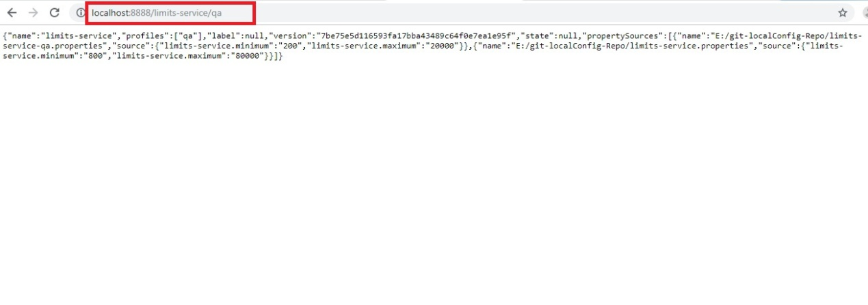

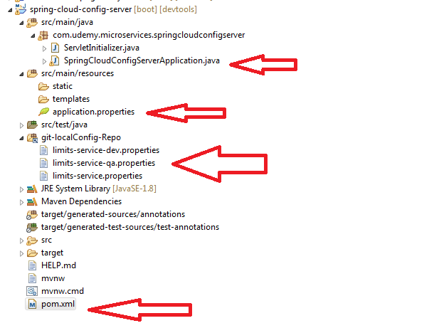

1. **Limits –Service:**

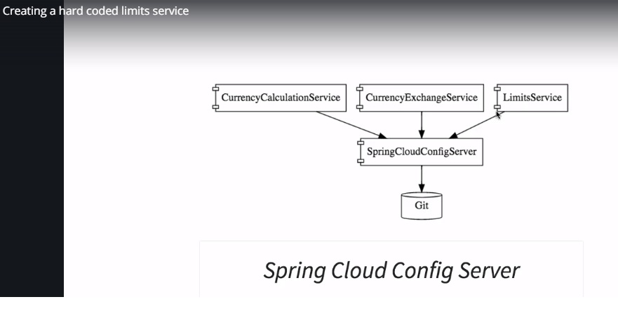

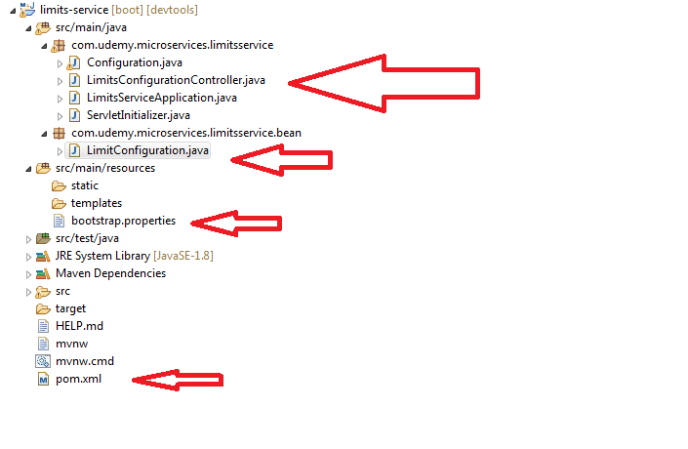

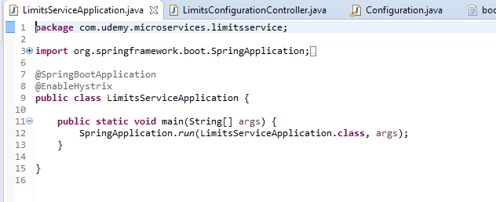

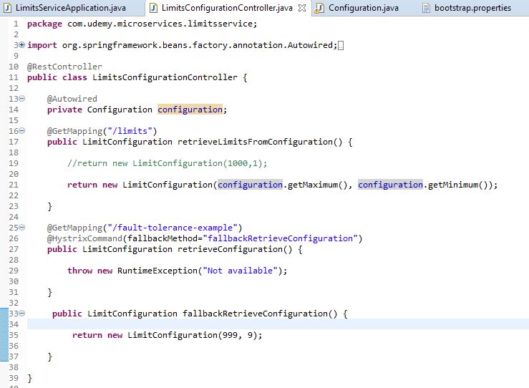

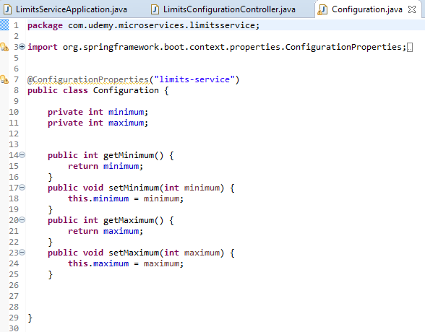

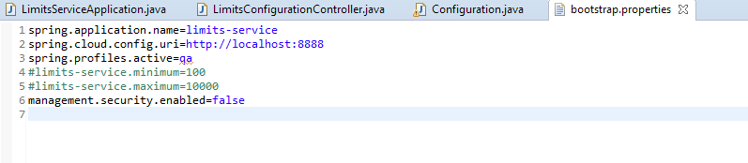

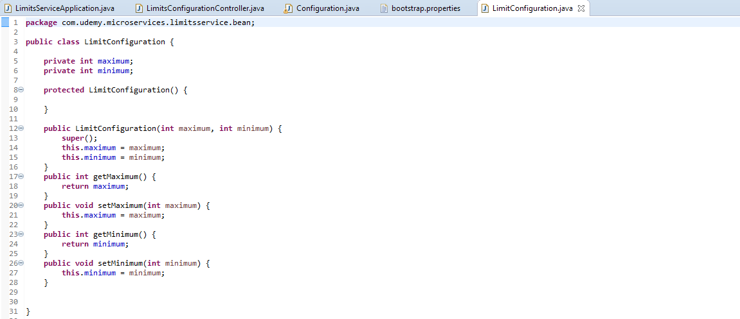

**pom.xml:**

<?xml version=*"1.0"* encoding=*"UTF-8"*?>

<project xmlns=*"http://maven.apache.org/POM/4.0.0"*

xmlns:xsi=*"http://www.w3.org/2001/XMLSchema-instance"*

xsi:schemaLocation=*"http://maven.apache.org/POM/4.0.0 http://maven.apache.org/xsd/maven-4.0.0.xsd"*>

<modelVersion>4.0.0</modelVersion>

<parent>

<groupId>org.springframework.boot</groupId>

<artifactId>spring-boot-starter-parent</artifactId>

<version>2.2.0.M4</version>

<relativePath /> <!-- lookup parent from repository -->

</parent>

<groupId>com.udemy.microservices</groupId>

<artifactId>limits-service</artifactId>

<version>0.0.1-SNAPSHOT</version>

<packaging>war</packaging>

<name>limits-service</name>

<description>Demo project for Spring Boot</description>

<properties>

<java.version>1.8</java.version>

<spring-cloud.version>Hoxton.M1</spring-cloud.version>

</properties>

<dependencies>

<dependency>

<groupId>org.springframework.boot</groupId>

<artifactId>spring-boot-starter-actuator</artifactId>

</dependency>

<dependency>

<groupId>org.springframework.boot</groupId>

<artifactId>spring-boot-starter-web</artifactId>

</dependency>

<dependency>

<groupId>org.springframework.cloud</groupId>

<artifactId>spring-cloud-starter-config</artifactId>

</dependency>

<dependency>

<groupId>org.springframework.cloud</groupId>

<artifactId>spring-cloud-starter-hystrix</artifactId>

<version>1.4.7.RELEASE</version>

</dependency>

<dependency>

<groupId>org.springframework.cloud</groupId>

<artifactId>spring-cloud-starter-bus-amqp</artifactId>

</dependency>

<dependency>

<groupId>org.springframework.boot</groupId>

<artifactId>spring-boot-devtools</artifactId>

<scope>runtime</scope>

<optional>true</optional>

</dependency>

<dependency>

<groupId>org.springframework.boot</groupId>

<artifactId>spring-boot-starter-tomcat</artifactId>

<scope>provided</scope>

</dependency>

<dependency>

<groupId>org.springframework.boot</groupId>

<artifactId>spring-boot-starter-test</artifactId>

<scope>test</scope>

<exclusions>

<exclusion>

<groupId>org.junit.vintage</groupId>

<artifactId>junit-vintage-engine</artifactId>

</exclusion>

<exclusion>

<groupId>junit</groupId>

<artifactId>junit</artifactId>

</exclusion>

</exclusions>

</dependency>

</dependencies>

<dependencyManagement>

<dependencies>

<dependency>

<groupId>org.springframework.cloud</groupId>

<artifactId>spring-cloud-dependencies</artifactId>

<version>${spring-cloud.version}</version>

<type>pom</type>

<scope>import</scope>

</dependency>

</dependencies>

</dependencyManagement>

<build>

<plugins>

<plugin>

<groupId>org.springframework.boot</groupId>

<artifactId>spring-boot-maven-plugin</artifactId>

</plugin>

</plugins>

</build>

<repositories>

<repository>

<id>spring-snapshots</id>

<name>Spring Snapshots</name>

<url>https://repo.spring.io/snapshot</url>

<snapshots>

<enabled>true</enabled>

</snapshots>

</repository>

<repository>

<id>spring-milestones</id>

<name>Spring Milestones</name>

<url>https://repo.spring.io/milestone</url>

</repository>

</repositories>

<pluginRepositories>

<pluginRepository>

<id>spring-snapshots</id>

<name>Spring Snapshots</name>

<url>https://repo.spring.io/snapshot</url>

<snapshots>

<enabled>true</enabled>

</snapshots>

</pluginRepository>

<pluginRepository>

<id>spring-milestones</id>

<name>Spring Milestones</name>

<url>https://repo.spring.io/milestone</url>

</pluginRepository>

</pluginRepositories>

</project>

1. **currency-exchange-service:**

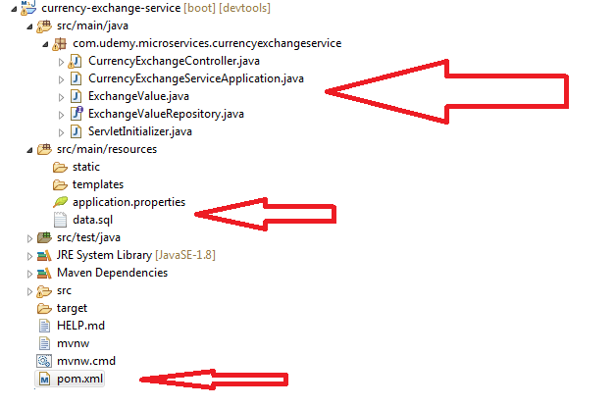

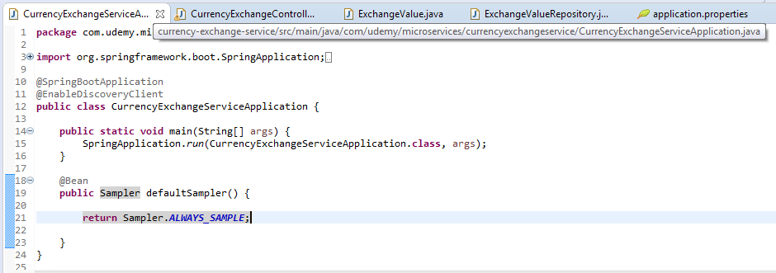

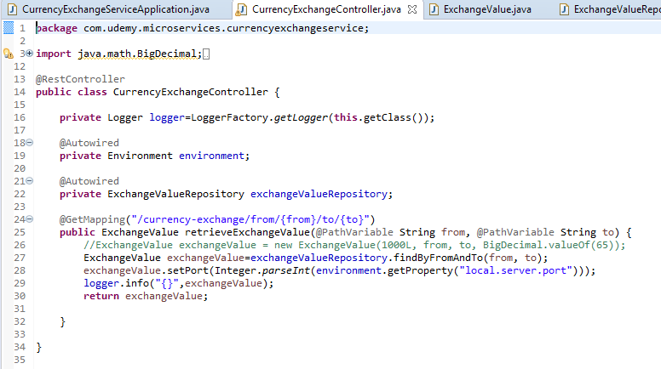

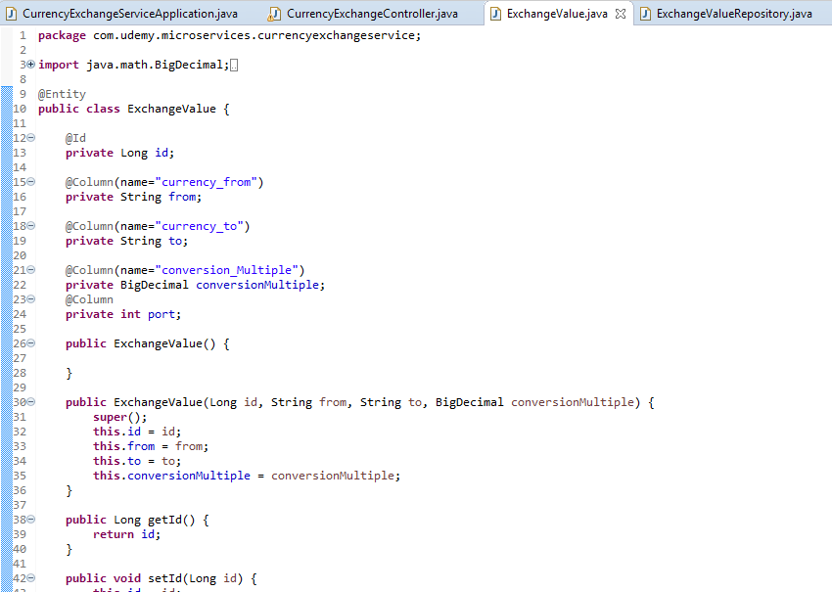

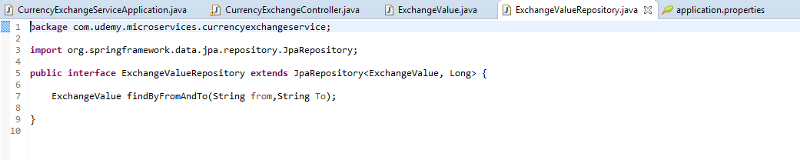

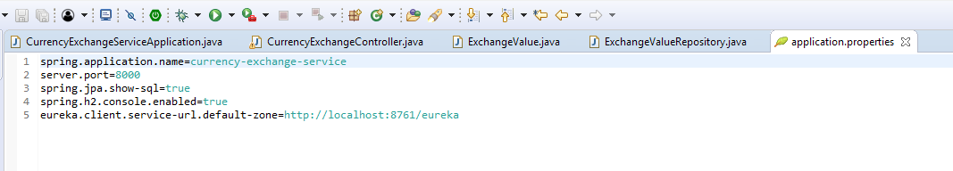

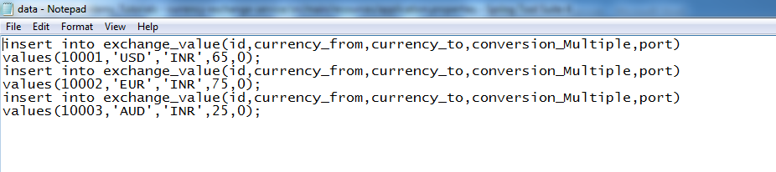

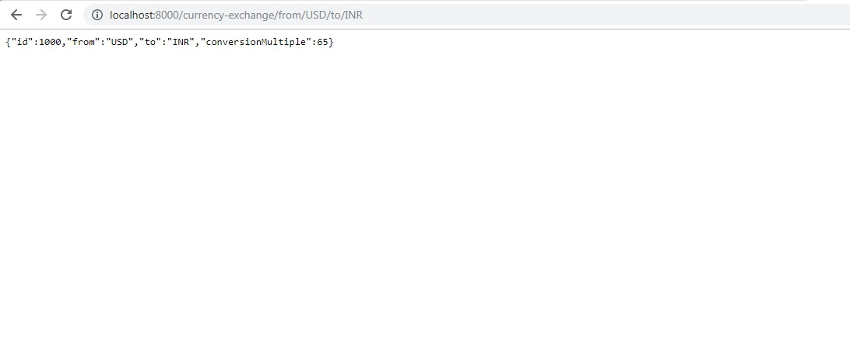

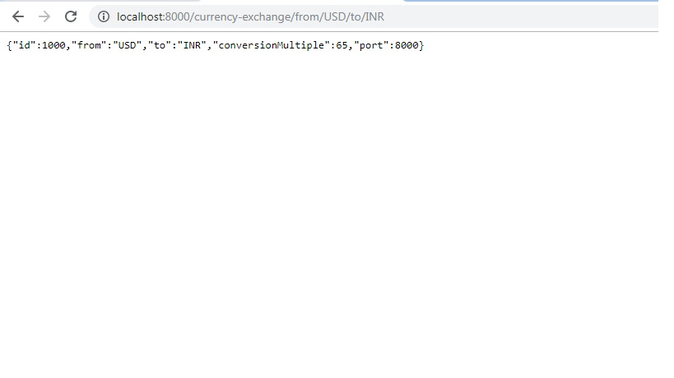

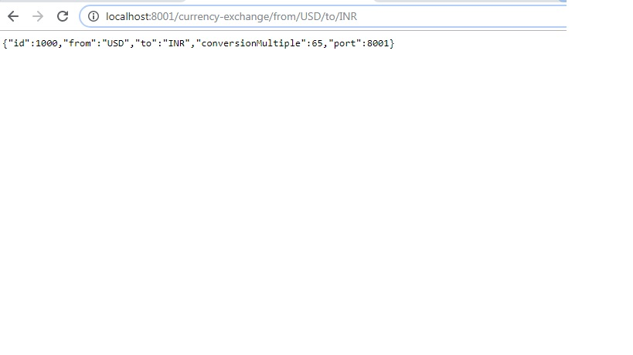

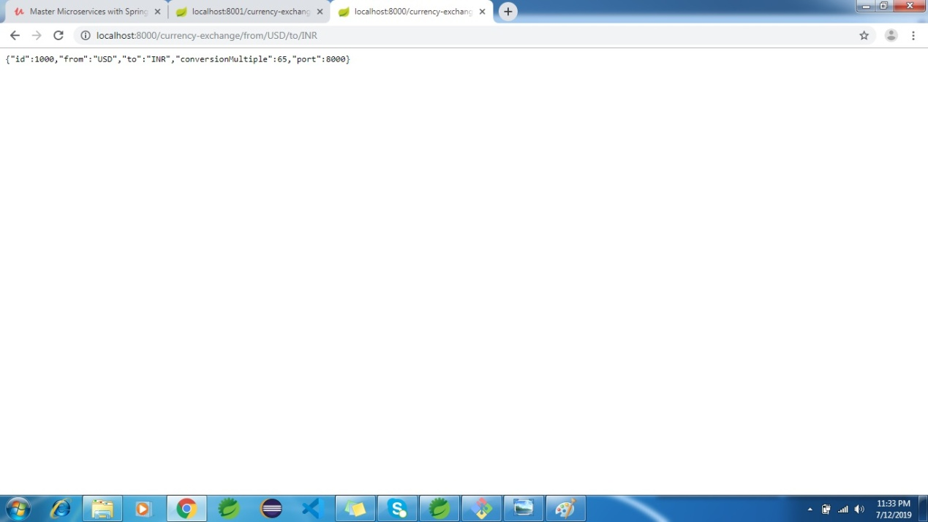

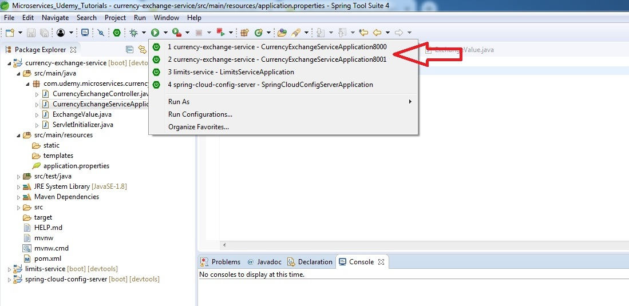

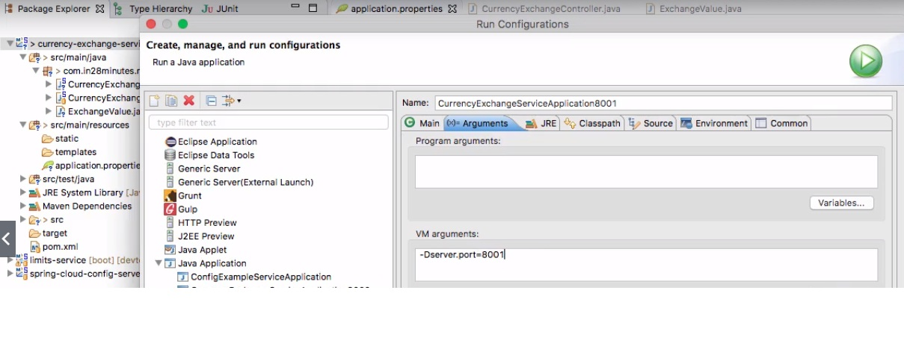

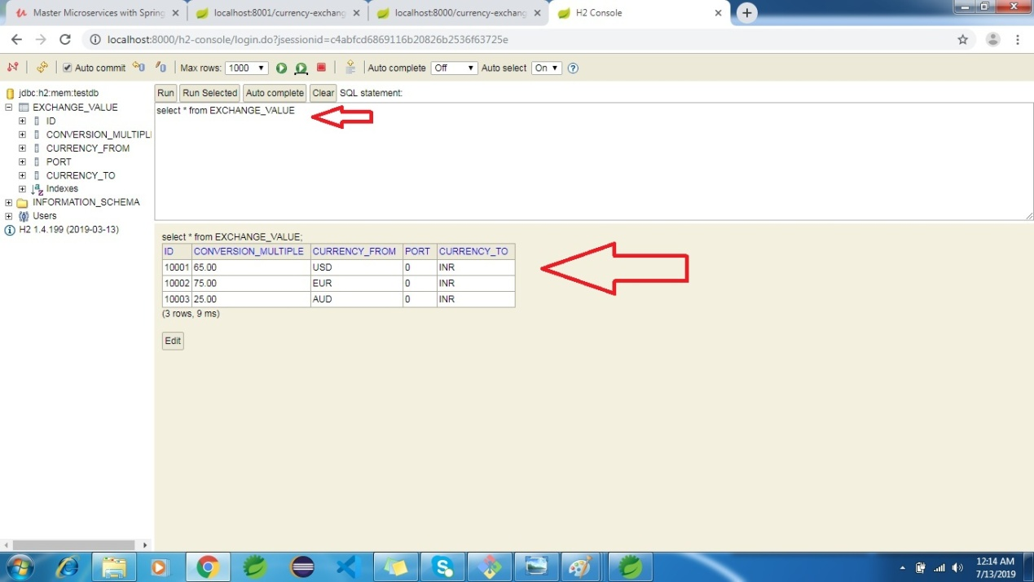

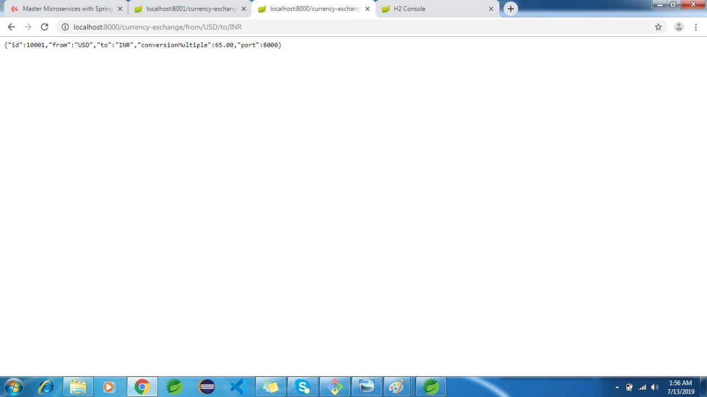

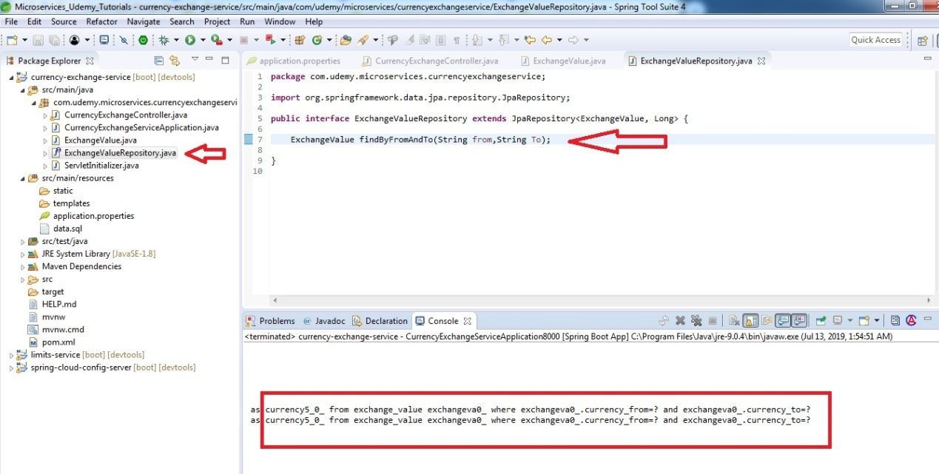

**pom.xml:**

<?xml version=*"1.0"* encoding=*"UTF-8"*?>

<project xmlns=*"http://maven.apache.org/POM/4.0.0"*

xmlns:xsi=*"http://www.w3.org/2001/XMLSchema-instance"*

xsi:schemaLocation=*"http://maven.apache.org/POM/4.0.0 http://maven.apache.org/xsd/maven-4.0.0.xsd"*>

<modelVersion>4.0.0</modelVersion>

<parent>

<groupId>org.springframework.boot</groupId>

<artifactId>spring-boot-starter-parent</artifactId>

<version>2.2.0.M4</version>

<relativePath /> <!-- lookup parent from repository -->

</parent>

<groupId>com.udemy.microservices</groupId>

<artifactId>currency-exchange-service</artifactId>

<version>0.0.1-SNAPSHOT</version>

<packaging>war</packaging>

<name>currency-exchange-service</name>

<description>Demo project for Spring Boot</description>

<properties>

<java.version>1.8</java.version>

<spring-cloud.version>Hoxton.M1</spring-cloud.version>

</properties>

<dependencies>

<dependency>

<groupId>org.springframework.boot</groupId>

<artifactId>spring-boot-starter-actuator</artifactId>

</dependency>

<dependency>

<groupId>org.springframework.boot</groupId>

<artifactId>spring-boot-starter-web</artifactId>

</dependency>

<dependency>

<groupId>org.springframework.boot</groupId>

<artifactId>spring-boot-starter-data-jpa</artifactId>

</dependency>

<dependency>

<groupId>com.h2database</groupId>

<artifactId>h2</artifactId>

</dependency>

<dependency>

<groupId>org.springframework.cloud</groupId>

<artifactId>spring-cloud-starter-config</artifactId>

</dependency>

<dependency>

<groupId>org.springframework.cloud</groupId>

<artifactId>spring-cloud-starter-eureka</artifactId>

<version>1.4.7.RELEASE</version>

</dependency>

<dependency>

<groupId>org.springframework.cloud</groupId>

<artifactId>spring-cloud-starter-sleuth</artifactId>

</dependency>

<!-- <dependency>

<groupId>org.springframework.cloud</groupId>

<artifactId>spring-cloud-sleuth-zipkin</artifactId>

</dependency> -->

<dependency>

<groupId>org.springframework.cloud</groupId>

<artifactId>spring-cloud-starter-zipkin</artifactId>

</dependency>

<!-- <dependency>

<groupId>org.springframework.cloud</groupId>

<artifactId>spring-cloud-starter-bus-amqp</artifactId>

</dependency> -->

<dependency>

<groupId>org.springframework.amqp</groupId>

<artifactId>spring-rabbit</artifactId>

</dependency>

<dependency>

<groupId>org.springframework.boot</groupId>

<artifactId>spring-boot-devtools</artifactId>

<scope>runtime</scope>

<optional>true</optional>

</dependency>

<dependency>

<groupId>org.springframework.boot</groupId>

<artifactId>spring-boot-starter-tomcat</artifactId>

<scope>provided</scope>

</dependency>

<dependency>

<groupId>org.springframework.boot</groupId>

<artifactId>spring-boot-starter-test</artifactId>

<scope>test</scope>

<exclusions>

<exclusion>

<groupId>org.junit.vintage</groupId>

<artifactId>junit-vintage-engine</artifactId>

</exclusion>

<exclusion>

<groupId>junit</groupId>

<artifactId>junit</artifactId>

</exclusion>

</exclusions>

</dependency>

</dependencies>

<dependencyManagement>

<dependencies>

<dependency>

<groupId>org.springframework.cloud</groupId>

<artifactId>spring-cloud-dependencies</artifactId>

<version>${spring-cloud.version}</version>

<type>pom</type>

<scope>import</scope>

</dependency>

</dependencies>

</dependencyManagement>

<build>

<plugins>

<plugin>

<groupId>org.springframework.boot</groupId>

<artifactId>spring-boot-maven-plugin</artifactId>

</plugin>

</plugins>

</build>

<repositories>

<repository>

<id>spring-snapshots</id>

<name>Spring Snapshots</name>

<url>https://repo.spring.io/snapshot</url>

<snapshots>

<enabled>true</enabled>

</snapshots>

</repository>

<repository>

<id>spring-milestones</id>

<name>Spring Milestones</name>

<url>https://repo.spring.io/milestone</url>

</repository>

</repositories>

<pluginRepositories>

<pluginRepository>

<id>spring-snapshots</id>

<name>Spring Snapshots</name>

<url>https://repo.spring.io/snapshot</url>

<snapshots>

<enabled>true</enabled>

</snapshots>

</pluginRepository>

<pluginRepository>

<id>spring-milestones</id>

<name>Spring Milestones</name>

<url>https://repo.spring.io/milestone</url>

</pluginRepository>

</pluginRepositories>

</project>

**4.currency-conversion-service:**

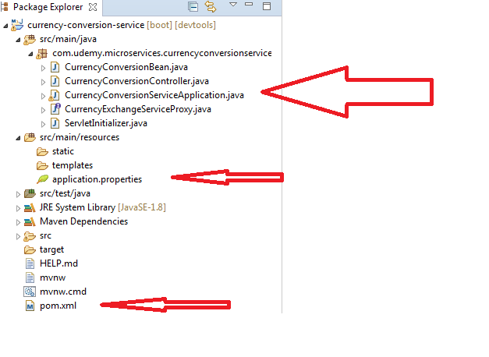

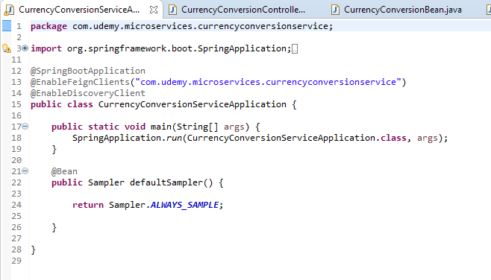

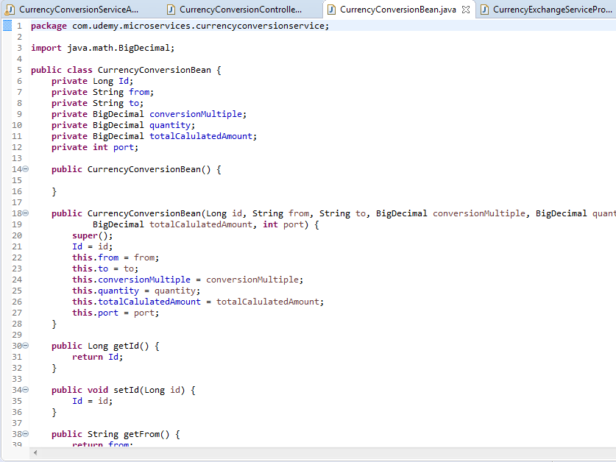

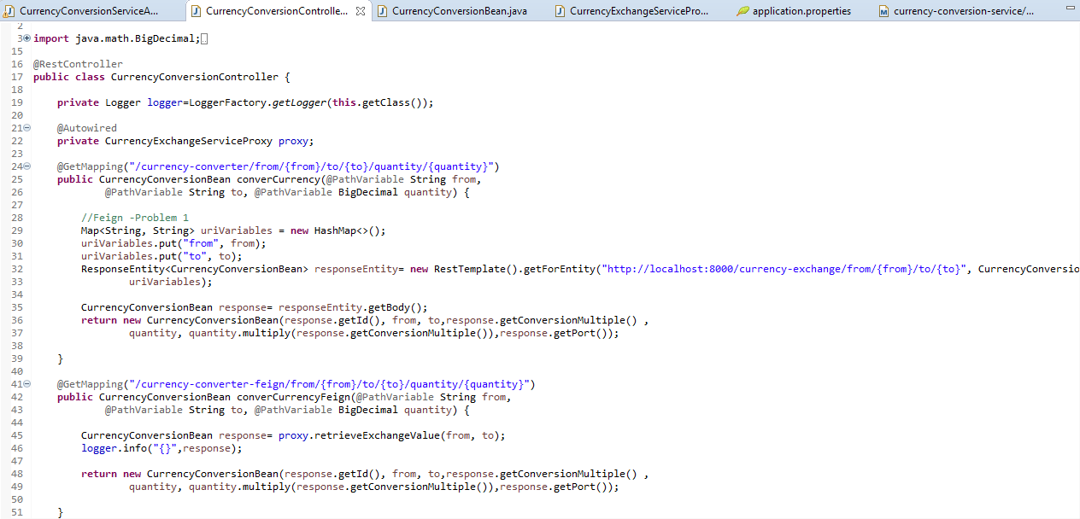

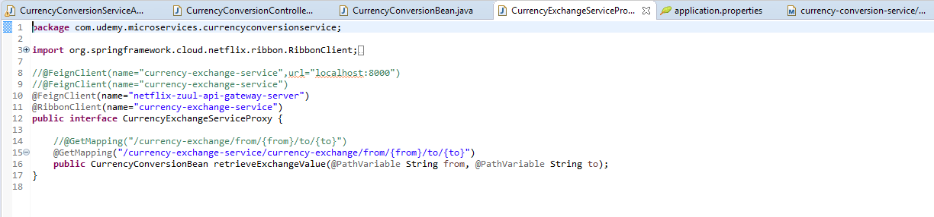

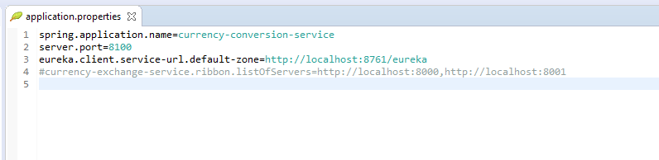

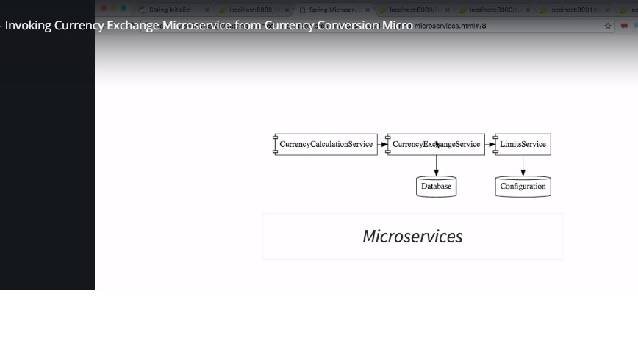

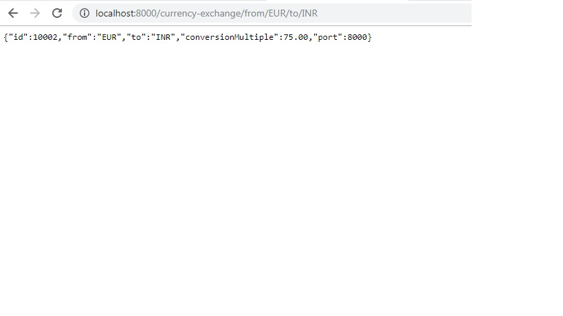

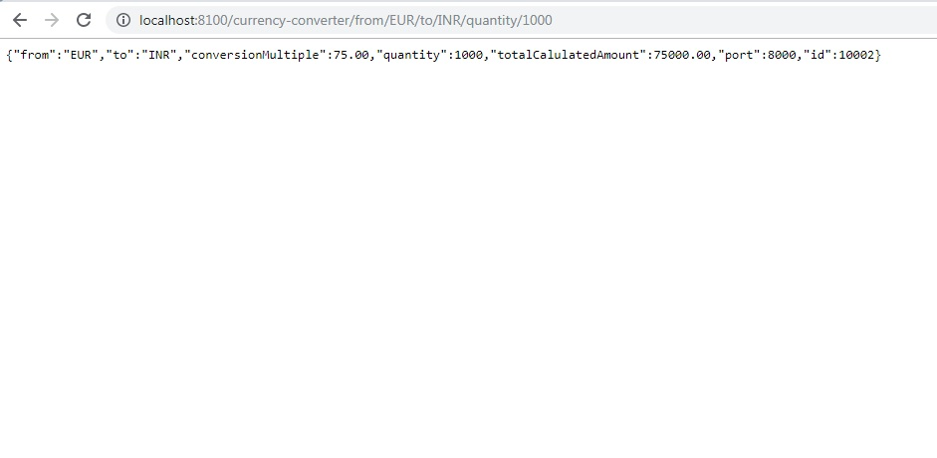

**pom.xml:**

<?xml version=*"1.0"* encoding=*"UTF-8"*?>

<project xmlns=*"http://maven.apache.org/POM/4.0.0"* xmlns:xsi=*"http://www.w3.org/2001/XMLSchema-instance"*

xsi:schemaLocation=*"http://maven.apache.org/POM/4.0.0 http://maven.apache.org/xsd/maven-4.0.0.xsd"*>

<modelVersion>4.0.0</modelVersion>

<parent>

<groupId>org.springframework.boot</groupId>

<artifactId>spring-boot-starter-parent</artifactId>

<version>2.2.0.M4</version>

<relativePath/> <!-- lookup parent from repository -->

</parent>

<groupId>com.udemy.microservices</groupId>

<artifactId>currency-conversion-service</artifactId>

<version>0.0.1-SNAPSHOT</version>

<packaging>war</packaging>

<name>currency-conversion-service</name>

<description>Demo project for Spring Boot</description>

<properties>

<java.version>1.8</java.version>

<spring-cloud.version>Hoxton.M1</spring-cloud.version>

</properties>

<dependencies>

<dependency>

<groupId>org.springframework.boot</groupId>

<artifactId>spring-boot-starter-actuator</artifactId>

</dependency>

<dependency>

<groupId>org.springframework.boot</groupId>

<artifactId>spring-boot-starter-web</artifactId>

</dependency>

<dependency>

<groupId>org.springframework.cloud</groupId>

<artifactId>spring-cloud-starter-config</artifactId>

</dependency>

<dependency>

<groupId>org.springframework.cloud</groupId>

<artifactId>spring-cloud-starter-feign</artifactId>

<version>1.4.7.RELEASE</version>

</dependency>

<dependency>

<groupId>org.springframework.cloud</groupId>

<artifactId>spring-cloud-starter-sleuth</artifactId>

</dependency>

<!-- <dependency>

<groupId>org.springframework.cloud</groupId>

<artifactId>spring-cloud-sleuth-zipkin</artifactId>

</dependency> -->

<dependency>

<groupId>org.springframework.cloud</groupId>

<artifactId>spring-cloud-starter-zipkin</artifactId>

</dependency>

<!-- <dependency>

<groupId>org.springframework.cloud</groupId>

<artifactId>spring-cloud-starter-bus-amqp</artifactId>

</dependency> -->

<dependency>

<groupId>org.springframework.amqp</groupId>

<artifactId>spring-rabbit</artifactId>

</dependency>

<dependency>

<groupId>org.springframework.cloud</groupId>

<artifactId>spring-cloud-starter-ribbon</artifactId>

<version>1.4.7.RELEASE</version>

</dependency>

<dependency>

<groupId>org.springframework.cloud</groupId>

<artifactId>spring-cloud-starter-eureka</artifactId>

<version>1.4.7.RELEASE</version>

</dependency>

<dependency>

<groupId>org.springframework.boot</groupId>

<artifactId>spring-boot-devtools</artifactId>

<scope>runtime</scope>

<optional>true</optional>

</dependency>

<dependency>

<groupId>org.springframework.boot</groupId>

<artifactId>spring-boot-starter-tomcat</artifactId>

<scope>provided</scope>

</dependency>

<dependency>

<groupId>org.springframework.boot</groupId>

<artifactId>spring-boot-starter-test</artifactId>

<scope>test</scope>

<exclusions>

<exclusion>

<groupId>org.junit.vintage</groupId>

<artifactId>junit-vintage-engine</artifactId>

</exclusion>

<exclusion>

<groupId>junit</groupId>

<artifactId>junit</artifactId>

</exclusion>

</exclusions>

</dependency>

</dependencies>

<dependencyManagement>

<dependencies>

<dependency>

<groupId>org.springframework.cloud</groupId>

<artifactId>spring-cloud-dependencies</artifactId>

<version>${spring-cloud.version}</version>

<type>pom</type>

<scope>import</scope>

</dependency>

</dependencies>

</dependencyManagement>

<build>

<plugins>

<plugin>

<groupId>org.springframework.boot</groupId>

<artifactId>spring-boot-maven-plugin</artifactId>

</plugin>

</plugins>

</build>

<repositories>

<repository>

<id>spring-snapshots</id>

<name>Spring Snapshots</name>

<url>https://repo.spring.io/snapshot</url>

<snapshots>

<enabled>true</enabled>

</snapshots>

</repository>

<repository>

<id>spring-milestones</id>

<name>Spring Milestones</name>

<url>https://repo.spring.io/milestone</url>

</repository>

</repositories>

<pluginRepositories>

<pluginRepository>

<id>spring-snapshots</id>

<name>Spring Snapshots</name>

<url>https://repo.spring.io/snapshot</url>

<snapshots>

<enabled>true</enabled>

</snapshots>

</pluginRepository>

<pluginRepository>

<id>spring-milestones</id>

<name>Spring Milestones</name>

<url>https://repo.spring.io/milestone</url>

</pluginRepository>

</pluginRepositories>

</project>

**Spring Cloud:**

Previously we developed microservices using Spring Boot. These were all stand alone applications. But suppose we now have to connect the various applications and build a distributed system.

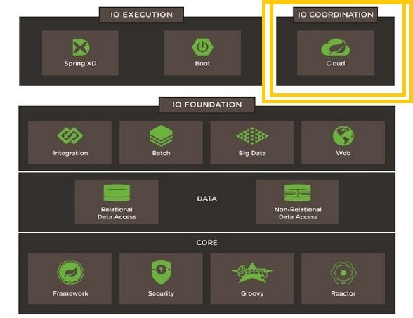

When developing distributed microservices with Spring Boot we face the following issues-

* **Complexity associated with distributed systems-**  
  This overhead includes network issues, Latency overhead, Bandwidth issues, security issues.
* **Service Discovery-**  
  Service discovery tools manage how processes and services in a cluster can find and talk to one another. It involves a directory of services, registering services in that directory, and then being able to lookup and connect to services in that directory.
* **Redundancy-**  
  Redundancy issues in distributed systems.
* **Loadbalancing-**  
  Load balancing improves the distribution of workloads across multiple computing resources, such as computers, a computer cluster, network links, central processing units, or disk drives.
* **Performance issues-**  
  Performance issues due to various operational overheads.
* **Deployment complexities-**  
  Requirement of Devops skills.

**Microservice Registration with Spring cloud using Netflix Eureka :**

In this series we learn how to use Netflix Spring Cloud Components. In this scenario we make use of Netflix component **Eureka** for service registry and discovery.

When we start a project, we usally have all the configurations in the properties file. As more and more services are developed and deployed, adding and modifying these properties become more complex. Some services might go down, while some the location might change. This manual changing of properties may create issues.

Eureka Service Registration and Discovery helps in such scenarios. As all services are registered to the Eureka server and lookup done by calling the Eureka Server, any change in service locations need not be handled and is taken care of.

**Overview of Netflix components-**

Spring Cloud Netflix provides Netflix OSS integrations for Spring Boot apps through auto configuration and binding to the Spring Environment and other Spring programming model idioms. With a few simple annotations you can quickly enable and configure the common patterns inside your application and build large distributed systems with battle-tested Netflix components. The patterns provided include Service Discovery (Eureka), Circuit Breaker (Hystrix), Intelligent Routing (Zuul) and Client Side Load Balancing (Ribbon).

|  |  |
| --- | --- |
| **Netflix Component Name** | **Functionality** |
| Eureka | Service Registration and Discovery |
| Ribbon | Dynamic Routing and Load Balancer |
| Hystrix | Circuit Breaker |
| Zuul | Edge Server |

**5.netflix –eureka-naming-server:**

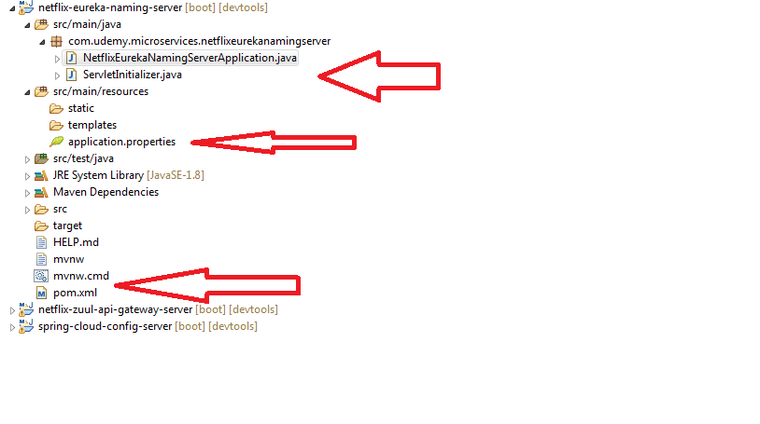

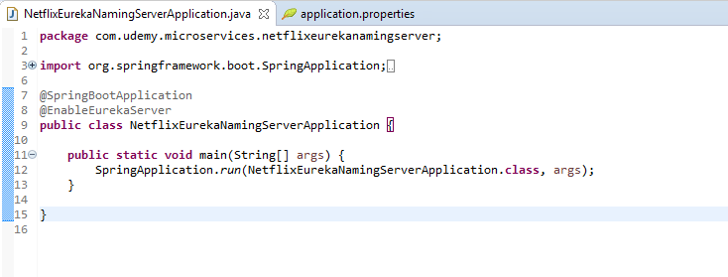

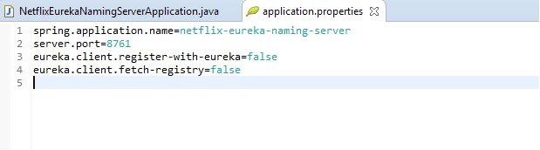

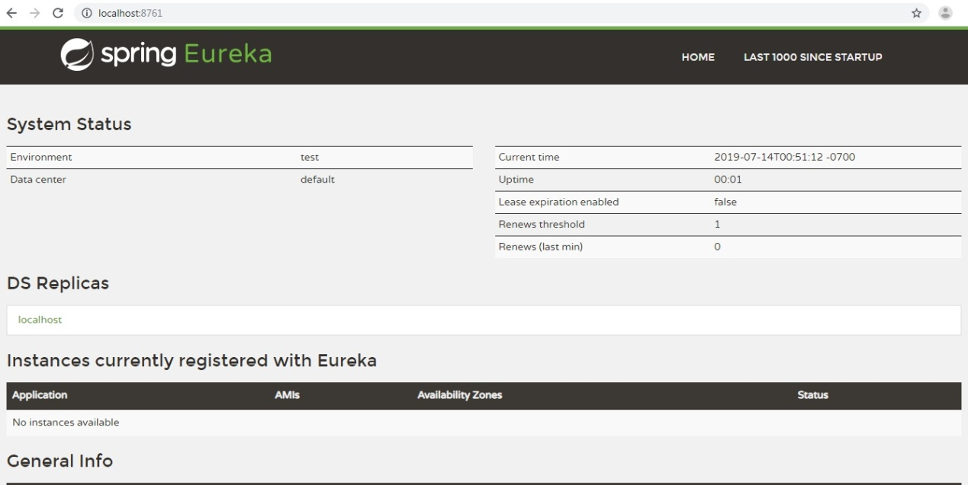

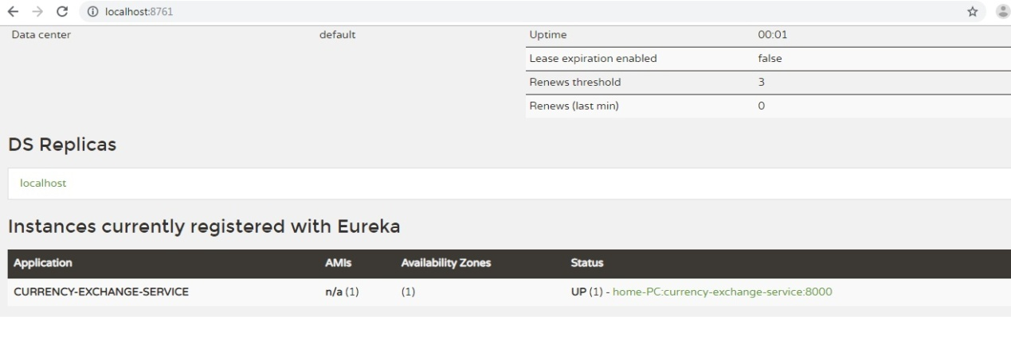

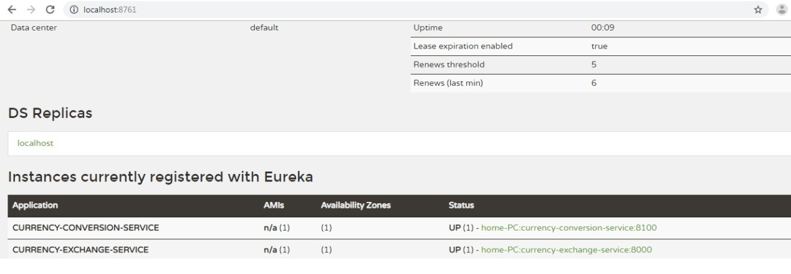

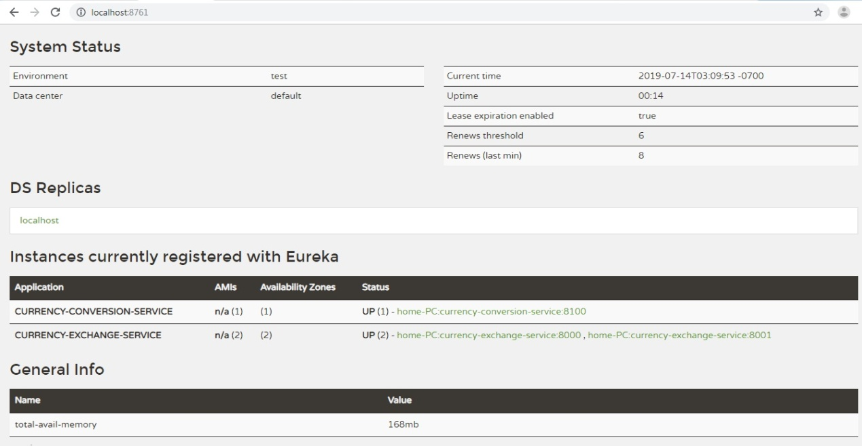

**pom.xml:**

<?xml version=*"1.0"* encoding=*"UTF-8"*?>

<project xmlns=*"http://maven.apache.org/POM/4.0.0"* xmlns:xsi=*"http://www.w3.org/2001/XMLSchema-instance"*

xsi:schemaLocation=*"http://maven.apache.org/POM/4.0.0 http://maven.apache.org/xsd/maven-4.0.0.xsd"*>

<modelVersion>4.0.0</modelVersion>

<parent>

<groupId>org.springframework.boot</groupId>

<artifactId>spring-boot-starter-parent</artifactId>

<version>2.2.0.M4</version>

<relativePath/> <!-- lookup parent from repository -->

</parent>

<groupId>com.udemy.microservices</groupId>

<artifactId>netflix-zuul-api-gateway-server</artifactId>

<version>0.0.1-SNAPSHOT</version>

<packaging>war</packaging>

<name>netflix-zuul-api-gateway-server</name>

<description>Demo project for Spring Boot</description>

<properties>

<java.version>1.8</java.version>

<spring-cloud.version>Hoxton.M1</spring-cloud.version>

</properties>

<dependencies>

<dependency>

<groupId>org.springframework.boot</groupId>

<artifactId>spring-boot-starter-actuator</artifactId>

</dependency>

<dependency>

<groupId>org.springframework.boot</groupId>

<artifactId>spring-boot-starter-web</artifactId>

</dependency>

<dependency>

<groupId>org.springframework.cloud</groupId>

<artifactId>spring-cloud-starter-netflix-eureka-client</artifactId>

</dependency>

<dependency>

<groupId>org.springframework.cloud</groupId>

<artifactId>spring-cloud-starter-netflix-zuul</artifactId>

</dependency>

<dependency>

<groupId>org.springframework.cloud</groupId>

<artifactId>spring-cloud-starter-sleuth</artifactId>

</dependency>

<!-- <dependency>

<groupId>org.springframework.cloud</groupId>

<artifactId>spring-cloud-sleuth-zipkin</artifactId>

</dependency> -->

<dependency>

<groupId>org.springframework.cloud</groupId>

<artifactId>spring-cloud-starter-zipkin</artifactId>

</dependency>

<!-- <dependency>

<groupId>org.springframework.cloud</groupId>

<artifactId>spring-cloud-starter-bus-amqp</artifactId>

</dependency> -->

<dependency>

<groupId>org.springframework.amqp</groupId>

<artifactId>spring-rabbit</artifactId>

</dependency>

<dependency>

<groupId>org.springframework.boot</groupId>

<artifactId>spring-boot-devtools</artifactId>

<scope>runtime</scope>

<optional>true</optional>

</dependency>

<dependency>

<groupId>org.springframework.boot</groupId>

<artifactId>spring-boot-starter-tomcat</artifactId>

<scope>provided</scope>

</dependency>

<dependency>

<groupId>org.springframework.boot</groupId>

<artifactId>spring-boot-starter-test</artifactId>

<scope>test</scope>

<exclusions>

<exclusion>

<groupId>org.junit.vintage</groupId>

<artifactId>junit-vintage-engine</artifactId>

</exclusion>

<exclusion>

<groupId>junit</groupId>

<artifactId>junit</artifactId>

</exclusion>

</exclusions>

</dependency>

</dependencies>

<dependencyManagement>

<dependencies>

<dependency>

<groupId>org.springframework.cloud</groupId>

<artifactId>spring-cloud-dependencies</artifactId>

<version>${spring-cloud.version}</version>

<type>pom</type>

<scope>import</scope>

</dependency>

</dependencies>

</dependencyManagement>

<build>

<plugins>

<plugin>

<groupId>org.springframework.boot</groupId>

<artifactId>spring-boot-maven-plugin</artifactId>

</plugin>

</plugins>

</build>

<repositories>

<repository>

<id>spring-snapshots</id>

<name>Spring Snapshots</name>

<url>https://repo.spring.io/snapshot</url>

<snapshots>

<enabled>true</enabled>

</snapshots>

</repository>

<repository>

<id>spring-milestones</id>

<name>Spring Milestones</name>

<url>https://repo.spring.io/milestone</url>

</repository>

</repositories>

<pluginRepositories>

<pluginRepository>

<id>spring-snapshots</id>

<name>Spring Snapshots</name>

<url>https://repo.spring.io/snapshot</url>

<snapshots>

<enabled>true</enabled>

</snapshots>

</pluginRepository>

<pluginRepository>

<id>spring-milestones</id>

<name>Spring Milestones</name>

<url>https://repo.spring.io/milestone</url>

</pluginRepository>

</pluginRepositories>

</project>

# Spring Cloud- Netflix Zuul + Eureka Simple Example:

Zuul is the front door for all requests from devices and web sites to the backend of the Netflix streaming application. As an edge service application, Zuul is built to enable dynamic routing, monitoring, resiliency and sec

What is the Netflix Zuul? Need for it?

Zuul is a JVM based router and server side load balancer by Netflix.   
It provides a single entry to our system, which allows a browser, mobile app, or other user interface to consume services from multiple hosts without managing cross-origin resource sharing (CORS) and authentication for each one. We can integrate Zuul with other Netflix projects like Hystrix for fault tolerance and Eureka for service discovery, or use it to manage routing rules, filters, and load balancing across your system.

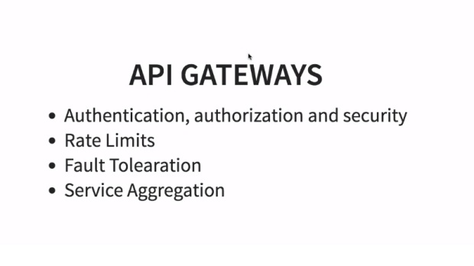

* Microservice call without Netflix Zuul.

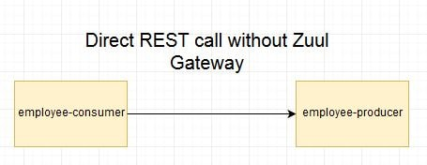

* Microservice call with Netflix Zuul

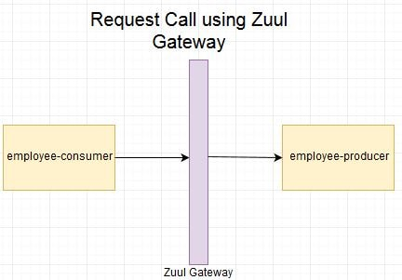

* Microservice call with Netflix Zuul + Netflix Eureka

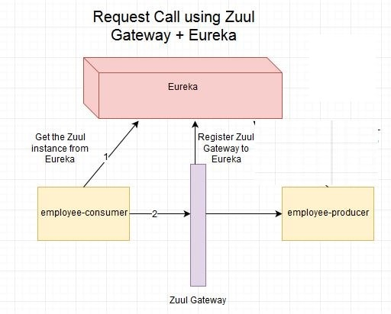

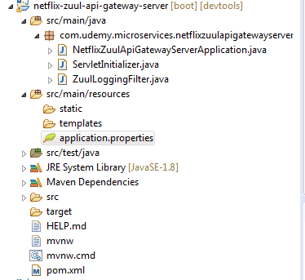

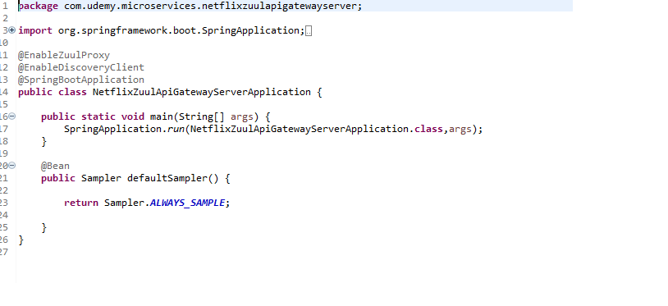

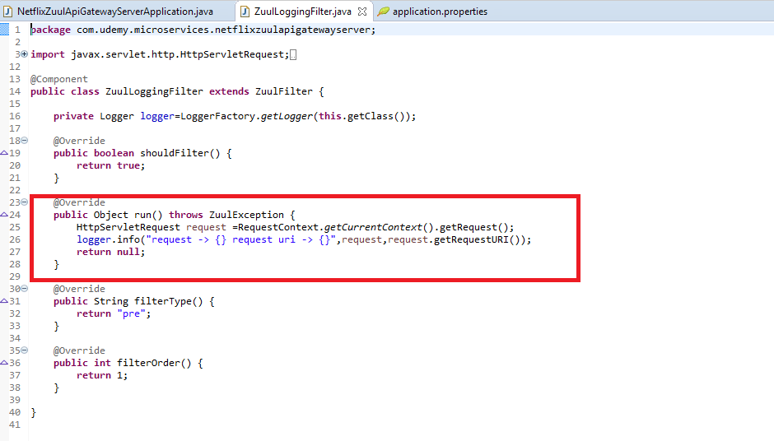

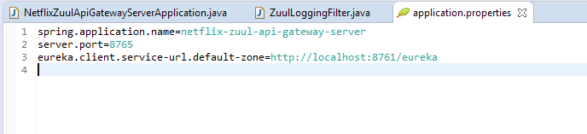

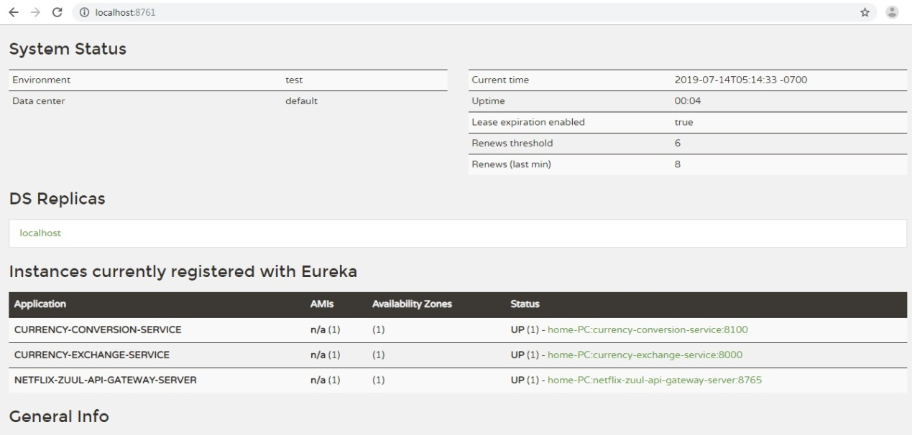

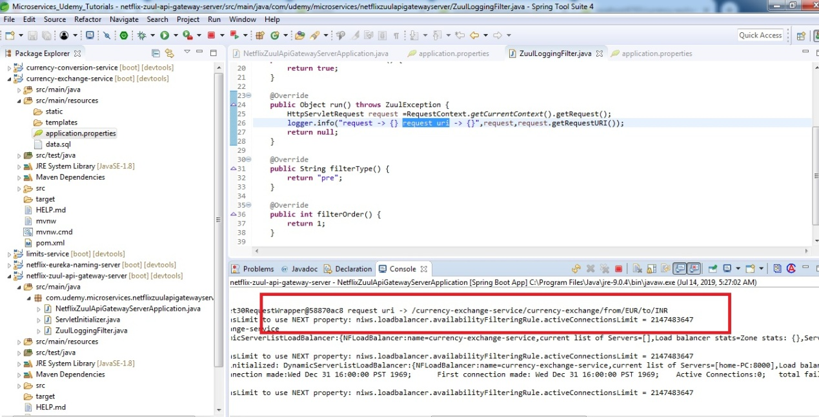

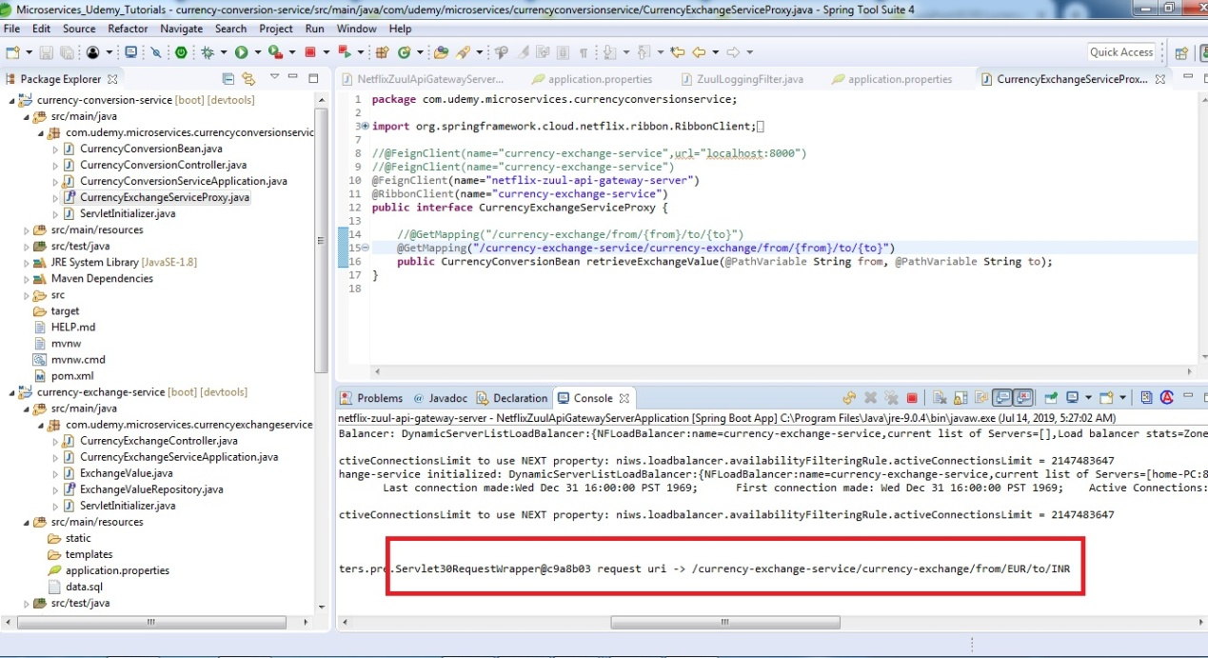

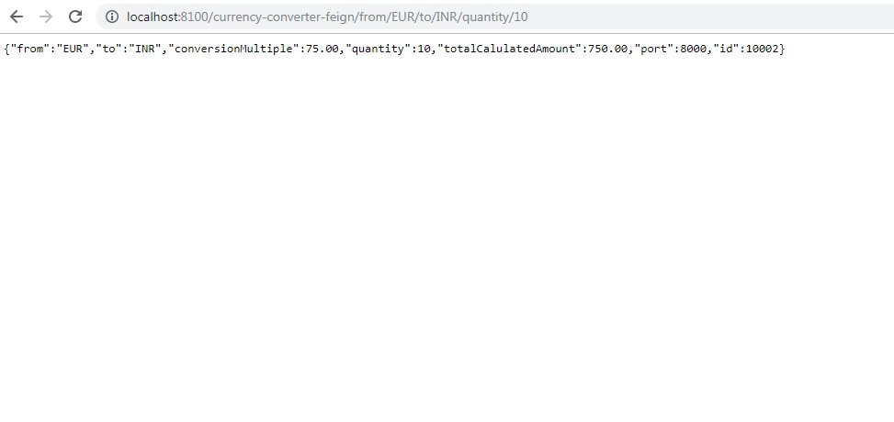

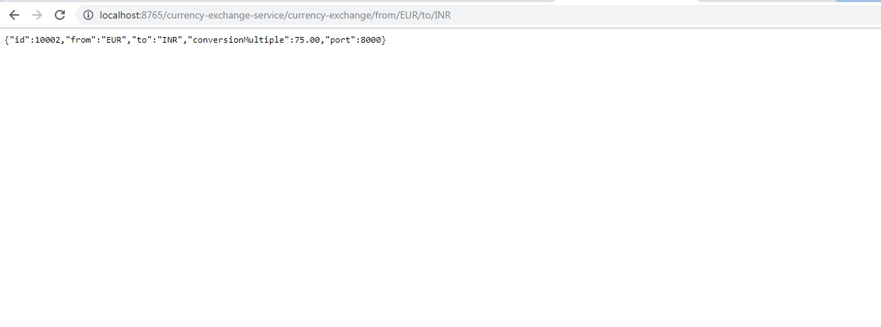

**pom.xml:**

<?xml version=*"1.0"* encoding=*"UTF-8"*?>

<project xmlns=*"http://maven.apache.org/POM/4.0.0"* xmlns:xsi=*"http://www.w3.org/2001/XMLSchema-instance"*

xsi:schemaLocation=*"http://maven.apache.org/POM/4.0.0 http://maven.apache.org/xsd/maven-4.0.0.xsd"*>

<modelVersion>4.0.0</modelVersion>

<parent>

<groupId>org.springframework.boot</groupId>

<artifactId>spring-boot-starter-parent</artifactId>

<version>2.2.0.M4</version>

<relativePath/> <!-- lookup parent from repository -->

</parent>

<groupId>com.udemy.microservices</groupId>

<artifactId>netflix-zuul-api-gateway-server</artifactId>

<version>0.0.1-SNAPSHOT</version>

<packaging>war</packaging>

<name>netflix-zuul-api-gateway-server</name>

<description>Demo project for Spring Boot</description>

<properties>

<java.version>1.8</java.version>

<spring-cloud.version>Hoxton.M1</spring-cloud.version>

</properties>

<dependencies>

<dependency>

<groupId>org.springframework.boot</groupId>

<artifactId>spring-boot-starter-actuator</artifactId>

</dependency>

<dependency>

<groupId>org.springframework.boot</groupId>

<artifactId>spring-boot-starter-web</artifactId>

</dependency>

<dependency>

<groupId>org.springframework.cloud</groupId>

<artifactId>spring-cloud-starter-netflix-eureka-client</artifactId>

</dependency>

<dependency>

<groupId>org.springframework.cloud</groupId>

<artifactId>spring-cloud-starter-netflix-zuul</artifactId>

</dependency>

<dependency>

<groupId>org.springframework.cloud</groupId>

<artifactId>spring-cloud-starter-sleuth</artifactId>

</dependency>

<!-- <dependency>

<groupId>org.springframework.cloud</groupId>

<artifactId>spring-cloud-sleuth-zipkin</artifactId>

</dependency> -->

<dependency>

<groupId>org.springframework.cloud</groupId>

<artifactId>spring-cloud-starter-zipkin</artifactId>

</dependency>

<!-- <dependency>

<groupId>org.springframework.cloud</groupId>

<artifactId>spring-cloud-starter-bus-amqp</artifactId>

</dependency> -->

<dependency>

<groupId>org.springframework.amqp</groupId>

<artifactId>spring-rabbit</artifactId>

</dependency>

<dependency>

<groupId>org.springframework.boot</groupId>

<artifactId>spring-boot-devtools</artifactId>

<scope>runtime</scope>

<optional>true</optional>

</dependency>

<dependency>

<groupId>org.springframework.boot</groupId>

<artifactId>spring-boot-starter-tomcat</artifactId>

<scope>provided</scope>

</dependency>

<dependency>

<groupId>org.springframework.boot</groupId>

<artifactId>spring-boot-starter-test</artifactId>

<scope>test</scope>

<exclusions>

<exclusion>

<groupId>org.junit.vintage</groupId>

<artifactId>junit-vintage-engine</artifactId>

</exclusion>

<exclusion>

<groupId>junit</groupId>

<artifactId>junit</artifactId>

</exclusion>

</exclusions>

</dependency>

</dependencies>

<dependencyManagement>

<dependencies>

<dependency>

<groupId>org.springframework.cloud</groupId>

<artifactId>spring-cloud-dependencies</artifactId>

<version>${spring-cloud.version}</version>

<type>pom</type>

<scope>import</scope>

</dependency>

</dependencies>

</dependencyManagement>

<build>

<plugins>

<plugin>

<groupId>org.springframework.boot</groupId>

<artifactId>spring-boot-maven-plugin</artifactId>

</plugin>

</plugins>

</build>

<repositories>

<repository>

<id>spring-snapshots</id>

<name>Spring Snapshots</name>

<url>https://repo.spring.io/snapshot</url>

<snapshots>

<enabled>true</enabled>

</snapshots>

</repository>

<repository>

<id>spring-milestones</id>

<name>Spring Milestones</name>

<url>https://repo.spring.io/milestone</url>

</repository>

</repositories>

<pluginRepositories>

<pluginRepository>

<id>spring-snapshots</id>

<name>Spring Snapshots</name>

<url>https://repo.spring.io/snapshot</url>

<snapshots>

<enabled>true</enabled>

</snapshots>

</pluginRepository>

<pluginRepository>

<id>spring-milestones</id>

<name>Spring Milestones</name>

<url>https://repo.spring.io/milestone</url>

</pluginRepository>

</pluginRepositories>

</project>

What is the Netflix Feign Client? Need for it?

Feign is a java to http client binder inspired by Retrofit, JAXRS-2.0, and WebSocket. Feign's first goal was reducing the complexity of binding Denominator uniformly to http apis regardless of restfulness. Previous examples in the **currency-conversion-service** we consumed the **REST services exposed by the currency-exchange-service** using **REST Template**.

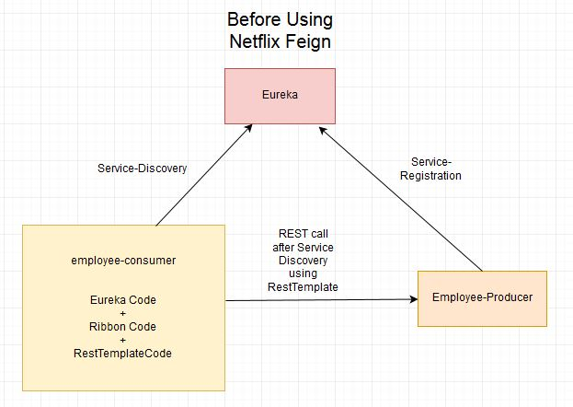

But we had to write a lot of code to perform following-

* For Load balancing using Ribbon.
* Getting the Service instance and then the Base URL.
* Make use of the REST Template for consuming service.

The previous code was as below:

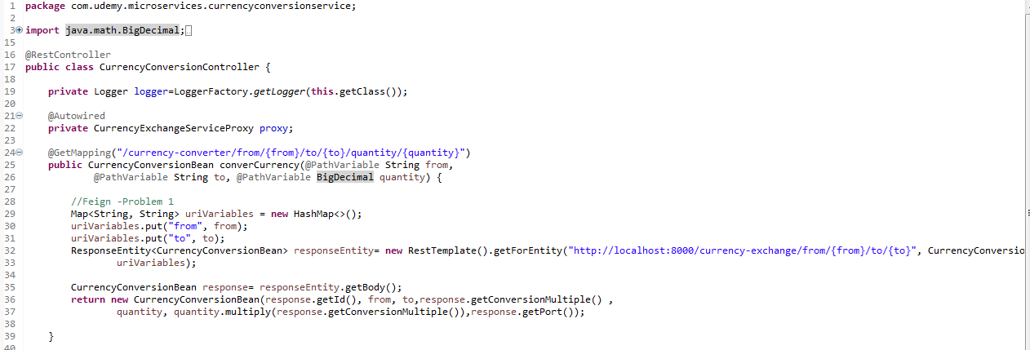

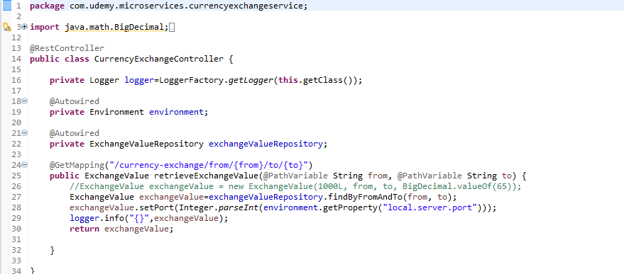

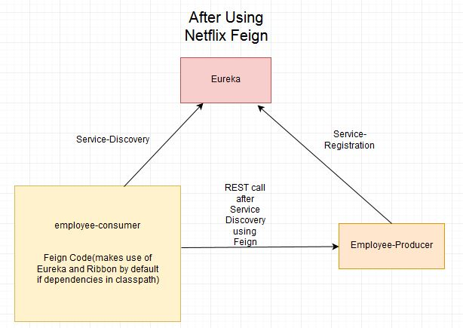

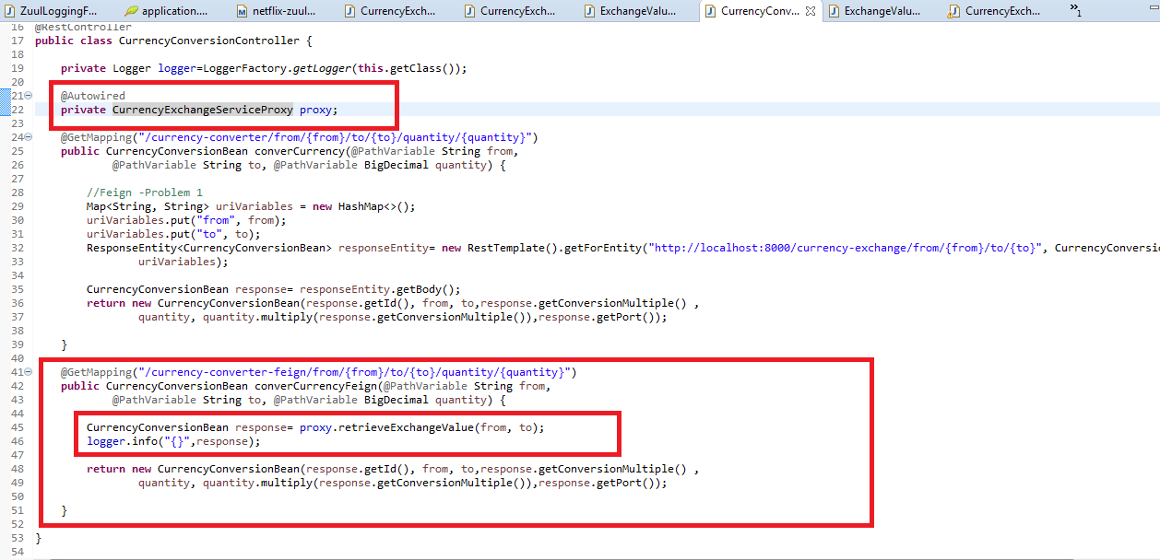

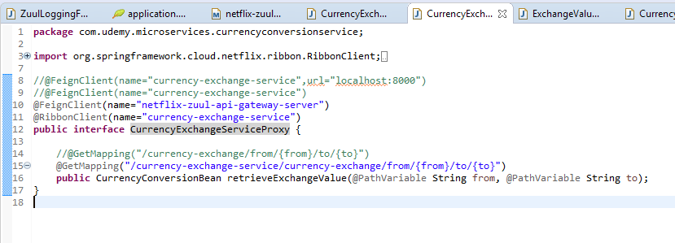

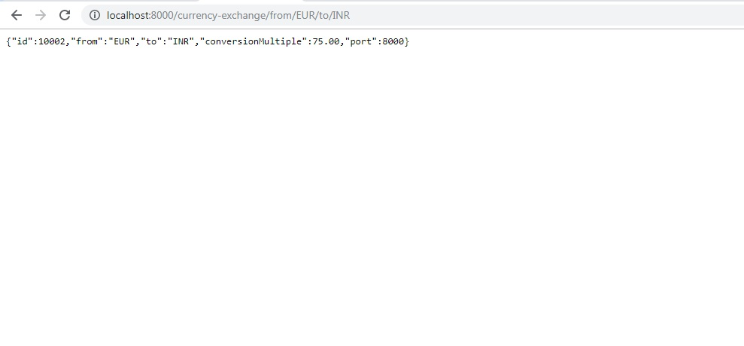

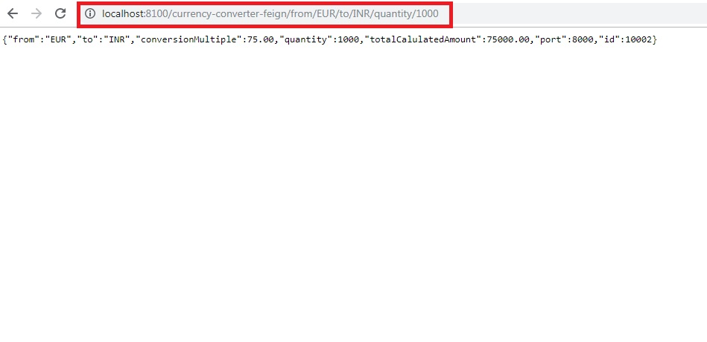

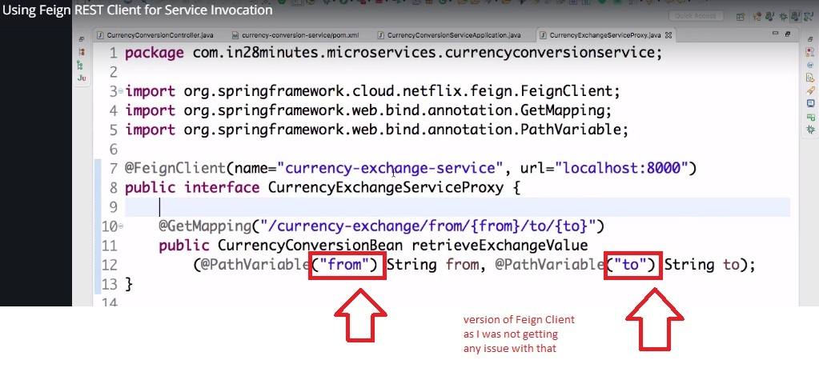

What is Load Balancing? Need for Netflix Ribbon

In computing, load balancing improves the distribution of workloads across multiple computing resources, such as computers, a computer cluster, network links, central processing units, or disk drives. Load balancing aims to optimize resource use, maximize throughput, minimize response time, and avoid overload of any single resource. Using multiple components with load balancing instead of a single component may increase reliability and availability through redundancy. Load balancing usually involves dedicated software or hardware, such as a multilayer switch or a Domain Name System server process.

In [previous posts we developed two services **currency-exchange-service** and **currency-conversion-service**](https://www.javainuse.com/spring/spring_eurekaregister). Suppose other modules are also calling and consuming **currency-exchange-service** module services. So the load at **currency-exchange-service** is high. To deal with this we this we deploy multiple instances of **currency-exchange-service**. Suppose two in this case. Now we will have to use a Load Balancer to route any incoming requests to either one of these two services.

**For Eg:**

